Java application inserts the DOB(Date of Birth),DOJ(Date of Joining),DOD(Date of Dead),DOM(Date of Marriage) TOB(Time of Birth),TOJ(Time of Joining),TOD(Time of Death) into DB table Column.

Java application retrieves the DOB(Date of Birth),DOJ(Date of Joining),DOD(Date of Dead),DOM(Date of Marriage) TOB(Time of Birth),TOJ(Time of Joining),TOD(Time of Death) from DB table Column.

**1.Oracle DB software:-**

**In oracle , Date pattern is : dd-MMM-yy**

Example:- 05-NOV-81

**In oracle, Timestamp pattern is: YYYY-MM-DD HR:MM:SS**

Example:- 1981-11-06 07:07:07

Oracle provided two data types which is date, time stamp.

Date data type column hold only date value.

Timestamp data type column hold both date and time values.

Note:- If JDBC application collect date and time values from the end user and JDBC application uses simple statement object to insert into DB table column then JDBC app has to request end user to give date and time values in the pattern that underlying DB software supports. So Use prepared Statement object instead of simple statement.

**2. What is diff between java.util.Date and java.sql.Date?**

Java.util.Date object holds both date and time values. It is not used for DB operations. Java 8 onwards, New api came. It provided following new classes.

Java.time.LocalDate:- It holds only date value.

Java.time.LocalTime:- It holds only time value.

Java.time.TimeStamp:- It holds both date and time.

These classes are not useful to DB operations.

Java.sql.date object holds only date value. It can be used in DB operations.

**3. Standard procedure to insert the date values to DB column values:**

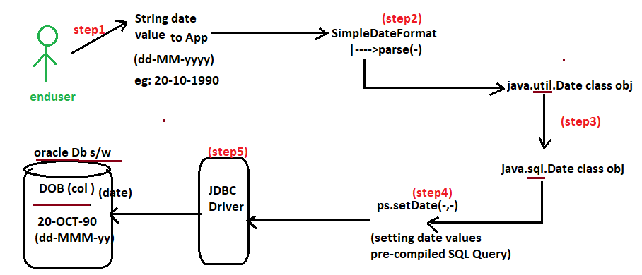

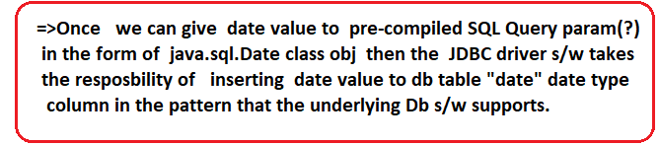

**3.1. Converting String date value to java.util.Date class object:**

**String s1=** “06-11-1981”.

SimpleDateFormat sf=new SimpleDateFormat(“DD-MM-YYYY”);

Java.util.Date udv= sf.parse(s1);

Note:- If string date value pattern is “YYYY-MM-DD”, then it can directly be converted to java.sql.date obj by valueOf() method of java.sql.Date Class.

String s2=”1981-11-06”.

Java.sql.Date sdv=java.sql.Date.valueOf(s2);

**3.2. Converting java.util.Date class object to java.Sql.Date object:**

**Long ms**= udf.getTime(); //This method returns date time value in the form of milliseconds.

Java.sql.Date sdv= new java.sql.Date(ms);

**4. Standard procedure to insert time and timestamp to DB table column**

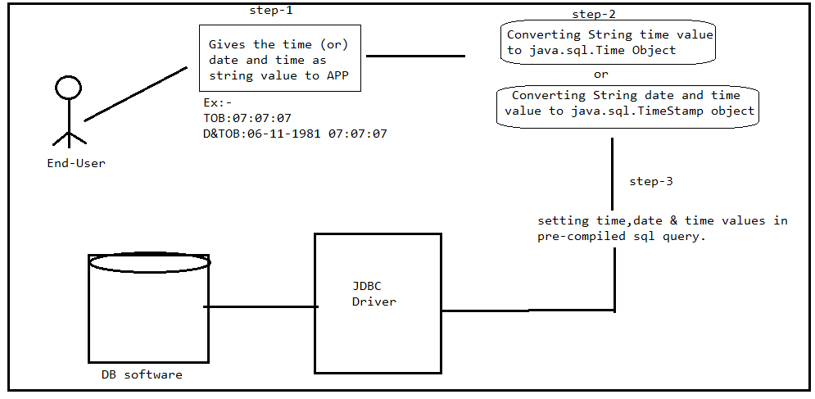

**4.1. Converting String time value to java.sql.Time object:**

String s1=”07:07:07”.

Java.sql.Time sqlTime=java.sql.Time.valueOf(s1);

**4.2. Converting String Date and time value to java.sql.timeStamp object**:

String s1=”06-11-1981”

SimpleDateFormat sf= new SimpleDateFormat(“DD-MM-YYYY HH:MM:SS”);

Java.util.Date sf1= sf.parse(s1);

Long ms=sf1.getTime();

Java.sql.TimeStamp odt=new java.sql.TimeStamp(ms);

Example:- Write JDBC application to insert customer name, bill_amt, DOB,TOP(Time of Purchase) and order date,time to oracle DB s/w.



import java.sql.Connection;

import java.sql.DriverManager;

import java.sql.PreparedStatement;

import java.sql.SQLException;

import java.sql.Time;

import java.text.SimpleDateFormat;

import java.util.Scanner;

public class Demo {

static String qur="Insert into customer values(?,?,?,?,?)";

public static void main(String[] args) {

try(

Connection con=DriverManager.getConnection("jdbc:oracle:thin:@localhost:1521:xe","sukumar","sukumar");

PreparedStatement ps=con.prepareStatement(qur);

Scanner s=new Scanner(System.in);

)

{

System.out.print("Enter the customerName:");

String cname=s.nextLine();

System.out.print("Enter the Bill Amount:");

float bamt=s.nextFloat();

s.nextLine();

System.out.print("Enter the DOB:");

String dob=s.nextLine();

System.out.print("Enter the Time of Purchase:");

String top=s.nextLine();

System.out.print("Enter the order date and time:");

String dtop=s.nextLine();

SimpleDateFormat sdf=new SimpleDateFormat("DD-MM-YYYY");

java.util.Date d=sdf.parse(dob);

java.sql.Date d1=new java.sql.Date(d.getTime());

java.sql.Time t1= java.sql.Time.valueOf(top);

sdf=new SimpleDateFormat("DD-MM-YYYY HH:MM:SS");

java.util.Date d2=sdf.parse(dtop);

java.sql.Timestamp t3=new java.sql.Timestamp(d2.getTime());

ps.setString(1, cname);

ps.setFloat(2, bamt);

ps.setDate(3,d1);

ps.setTime(4,t1);

ps.setTimestamp(5, t3);

int count=ps.executeUpdate();

if(count!=0) {

System.out.println("Record inserted Successfully");

}

else {

System.out.println("Record Not inserted");

}

}

catch(SQLException e) {

System.out.println(e.getMessage());

}

catch(Exception e) {

System.out.println(e.getMessage());

}

}

}

Output:-

Enter the customerName:suku

Enter the Bill Amount:70

Enter the DOB:06-11-1981

Enter the Time of Purchase:07:07:07

Enter the order date and time:06-11-1981 07:07:07

Record inserted Successfully

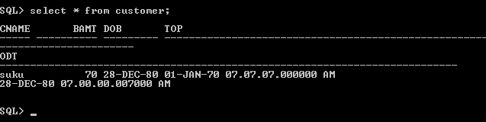

5.Standard procedure to retrieve date,time and date,time from columns of DB table:

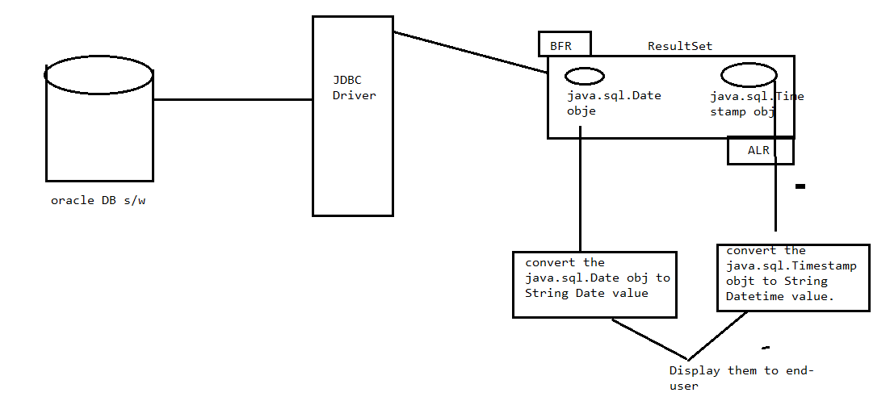

5.1. converting java.sql.Date/java.util.Date object to String date value:

SimpleDateFormat sdf=new SimpleDateFormat(“MMM-DD-YYYY”);

String v1=sdf.format(java.sql.Date/java.util.Date object);

5.2. converting java.sql.Timestamp obj data as String value:

Sqdt 🡪 it is java.sql.Timestamp object name.

Long ms=sqdt.getTime();

Java.util.Date d1=new java.util.Date(ms);

simpleDateFormat sf=new simpleDateFormat(“hh:mm:ss MMM/YYY/dd”);

String sd=sf.format(d1);

Example:-

import java.sql.Connection;

import java.sql.DriverManager;

import java.sql.PreparedStatement;

import java.sql.ResultSet;

import java.sql.SQLException;

import java.text.SimpleDateFormat;

import java.util.Scanner;

public class Demo {

static String qur="select * from customer";

public static void main(String[] args) {

try(

Connection con=DriverManager.getConnection("jdbc:oracle:thin:@localhost:1521:xe","sukumar","sukumar");

PreparedStatement ps=con.prepareStatement(qur);

ResultSet r1=ps.executeQuery();

Scanner s=new Scanner(System.in);

)

{

r1.next();

System.out.println("CustomerName:"+r1.getString(1));

System.out.println("BillAmt:"+r1.getFloat(2));

java.sql.Date d1=r1.getDate(3);

SimpleDateFormat sf=new SimpleDateFormat("dd-MM-YYYY");

String dob=sf.format(d1);

System.out.println("Customer DOB:"+dob);

java.sql.Timestamp st=r1.getTimestamp(4);

long ms=st.getTime();

java.util.Date ud=new java.util.Date(ms);

sf=new SimpleDateFormat("HH:MM:SS");

String top=sf.format(ud);

System.out.println("Time of Purchasing:"+top);

st=r1.getTimestamp(5);

ms=st.getTime();

ud=new java.util.Date(ms);

sf=new SimpleDateFormat("dd-MMM-YYYY hh:mm:ss");

String dtop=sf.format(ud);

System.out.println("Order date and time:"+dtop);

}

catch(SQLException e) {

System.out.println(e.getMessage());

}

catch(Exception e) {

System.out.println(e.getMessage());

}

}

}

Output:-

CustomerName:suku

BillAmt:70.0

Customer DOB:28-12-1981

Time of Purchasing:07:01:00

Order date and time:28-Dec-1981 07:00:00